Application UML Architecture
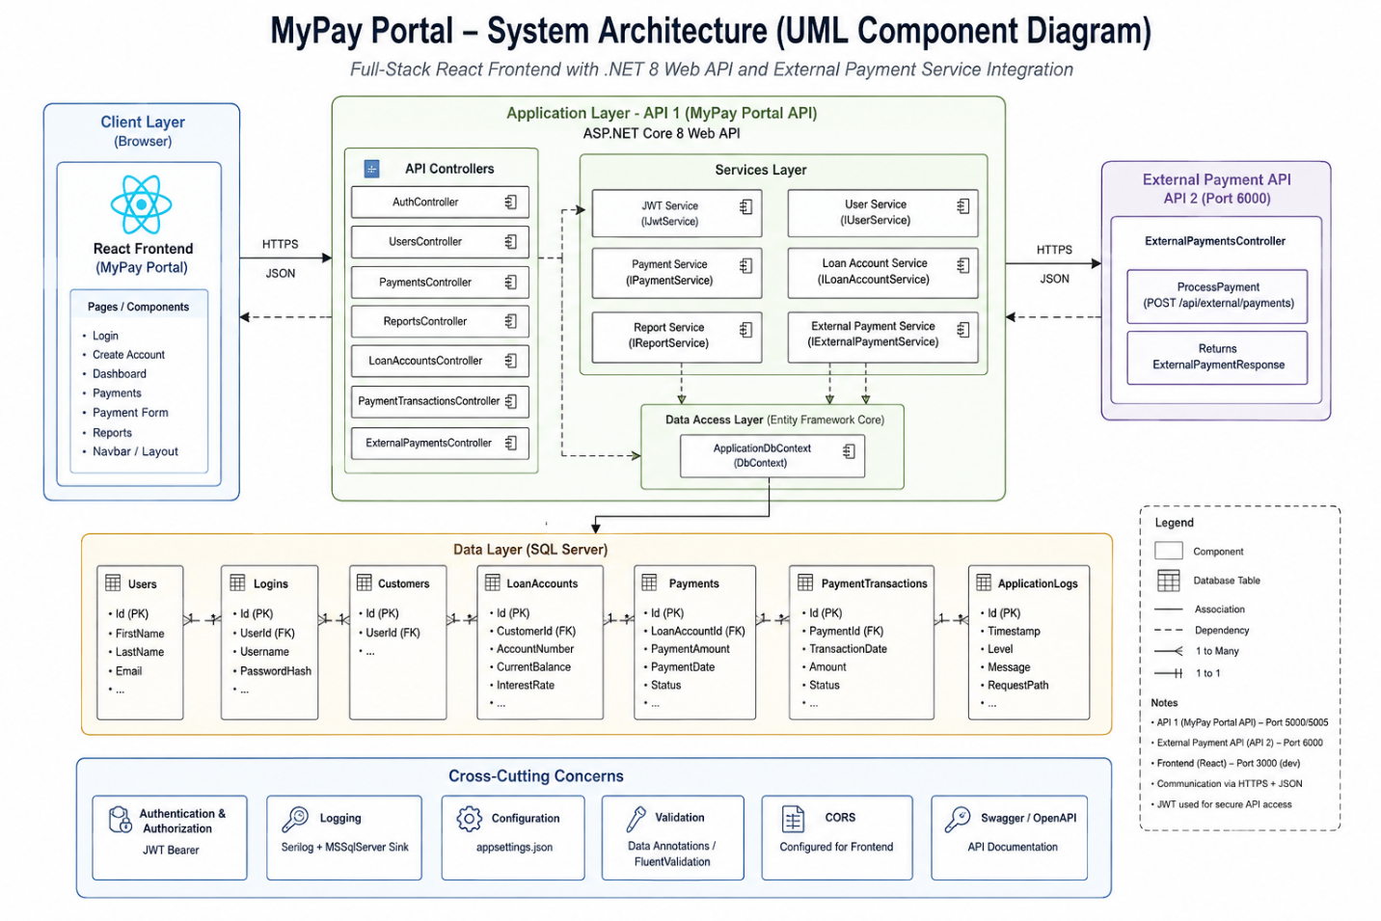

Database Diagram.
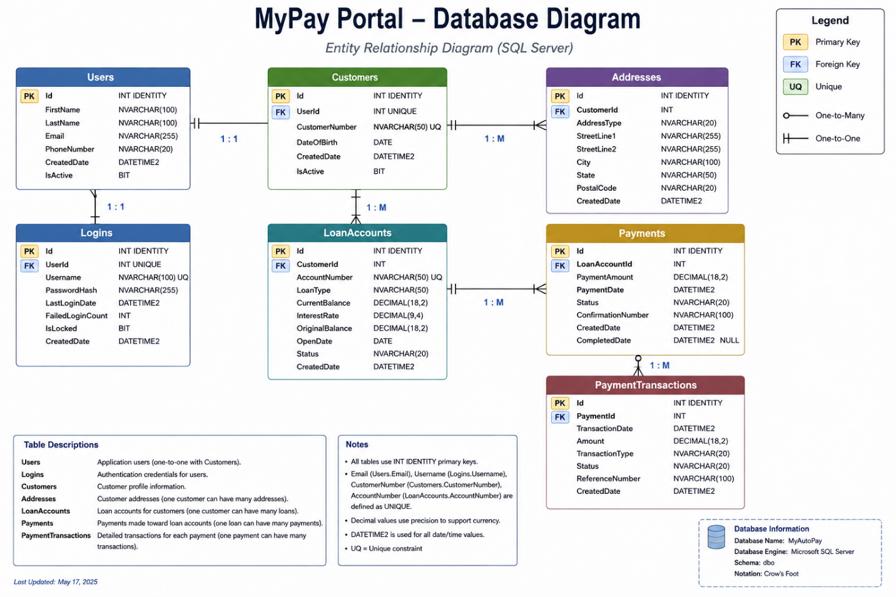

Database ERD Diagram.
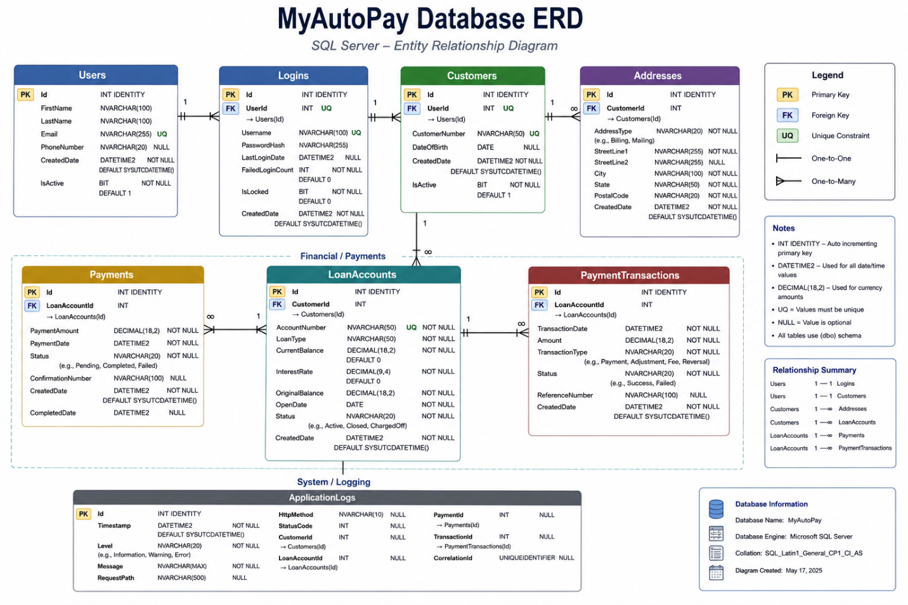

Payment Processing Flow Diagram.
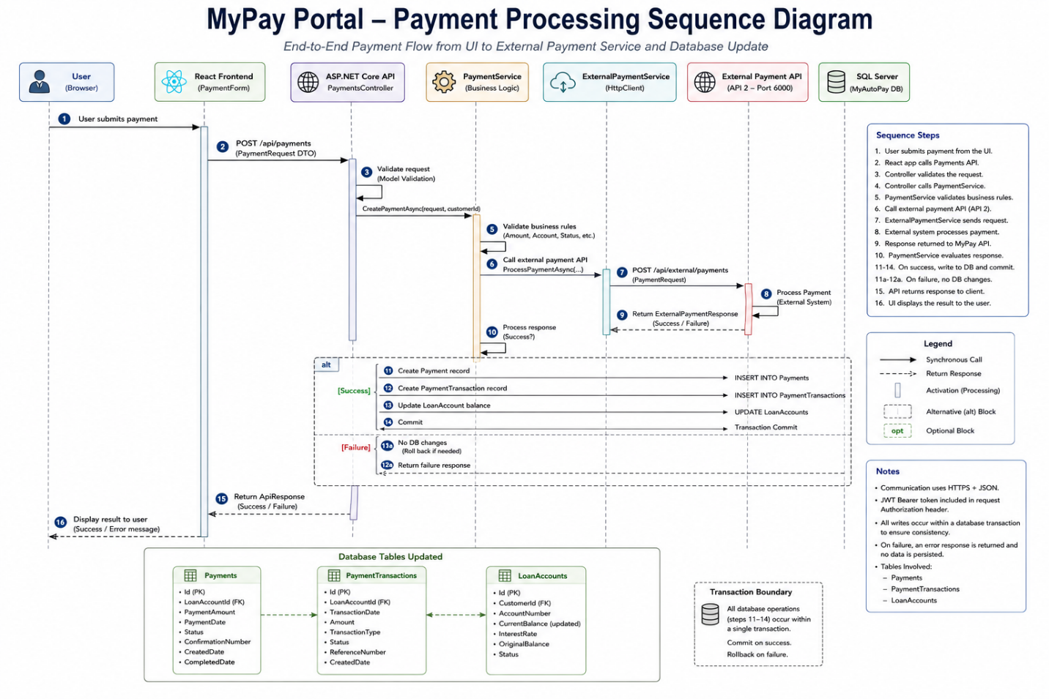

Tech Stack Versioning Table.
Layer / Category | Technology | Version | Purpose
Frontend | React | 19.2.8 | User interface and component-based frontend
Frontend | JavaScript | ES6+ | Frontend application logic
Frontend | Bootstrap | 5.3.8 | Responsive UI and styling
Frontend | React Icons | 5.7.0 | UI icons
Frontend | jsPDF | 4.2.1 | Client-side report/PDF generation
Frontend Runtime | Node.js | 20.11.0 | JavaScript runtime / development environment
Package Manager | npm | 10.8.2 | Frontend dependency management
Frontend Dev Server | Vite | 8.2.0 | React development/build tooling
Backend | C# | .NET 8 | Backend programming language
Backend | ASP.NET Core Web API | .NET 8 | REST API
ORM / Data Access | Entity Framework Core | 8.0.0 | Object-relational mapping and database access
Database Provider | EF Core SQL Server | 8.0.0 | SQL Server database connectivity
Authentication | JWT Bearer Authentication | 8.0.0 | API authentication and authorization
Authentication | System.IdentityModel.Tokens.Jwt | 8.16.0 | JWT creation/validation
API Documentation | Swashbuckle.AspNetCore | 10.2.3 | Swagger / OpenAPI documentation
Logging | Serilog.AspNetCore | 10.0.0 | Application logging
Logging | Serilog.Settings.Configuration | 10.0.1 | Serilog configuration
Logging | Serilog.Sinks.MSSqlServer | 10.0.0 | Writing application logs to SQL Server
Database | Microsoft SQL Server | Not specified | Primary relational database
Database | T-SQL | SQL Server | Database schema, queries and stored database operations
API Integration | HTTP / REST / JSON | — | Communication between MyPay Portal API and external payment API
External Service | External Payment API | API 2 | Payment-processing service integration
Testing | xUnit | Not specified | Backend unit/API testing
Testing | ASP.NET Core Test Infrastructure | .NET 8 | API testing
Version Control | Git | Not specified | Source control
Repository | GitHub | — | Remote source-code repository
Development Environment | Visual Studio / VS Code | Not specified | Application development

